Name:_________________________________
Photosynthesis Equation:
6CO₂ + 6 H₂O → C₆H₁₂O₆ + 6 O₂

What is photosynthesis?

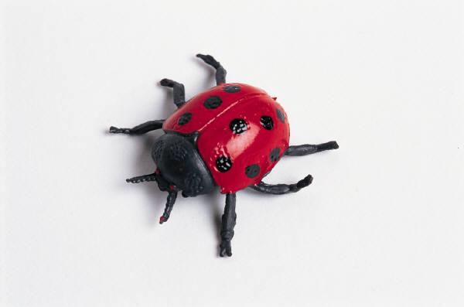
Respiration Equation:
C₆H₁₂O₆ + 6 O₂ → 6CO₂ + 6 H₂O

What is Respiration?

Name:_________________________________
Photosynthesis Equation:
6CO₂ + 6 H₂O → C₆H₁₂O₆ + 6 O₂

What is photosynthesis?

Respiration Equation:
C₆H₁₂O₆ + 6 O₂ → 6CO₂ + 6 H₂O

What is Respiration?

