Name:________________________________ Earth Science Final Study Guide: Both Trimesters

Define the following:
- Surface tension:

- Condensation:

- Polar:

- Transpiration:

- Precipitation:

- Evaporation

- Surface runoff:

- Ground infiltration

- Determine why communities treat water and how they might manage water as a non-renewable resource.

- What are physical and chemical properties of water and how they affect water ecosystems?

- Describe the water cycle. Where does most of our water on our earth come from?

- How does energy move water in the ocean?

Describe the physical dynamics of oceans for each of the following words:
- Waves:

- Tides:

- Surface currents:

- Deep ocean currents:

- Upwellings:

- Describe the basic composition of the atmosphere in the types of gases and the percentage of each:

Name the five layers of the atmosphere and the most important facts about each.
Atmospheric Layer | Important Facts of that layer.

- Explain the significance of ozone in the upper and lower atmosphere

- What is the hole in ozone? What substances cause it? What harm does the hole in the ozone cause?

- Describe how energy from the sun moves in the atmosphere (eg. conduction, convection, and radiation).

- Illustrate the causes of wind and identify some local winds.

- Differentiate between weather and climate.

- Describe how latitude affects climate. Include the three main regions and explain the four seasons (which hemisphere is pointing towards the sun, etc.)

- Summarize 5 natural reasons for climate change.

- Differentiate between global warming and the greenhouse effect.

- Identify two things that humans are doing that could alter the climate.

- Describe five main air masses. Include: their characteristics, how they form and how they influence weather.

- Define the Coriolis Effect and be able to

- Draw and name global winds on this map:
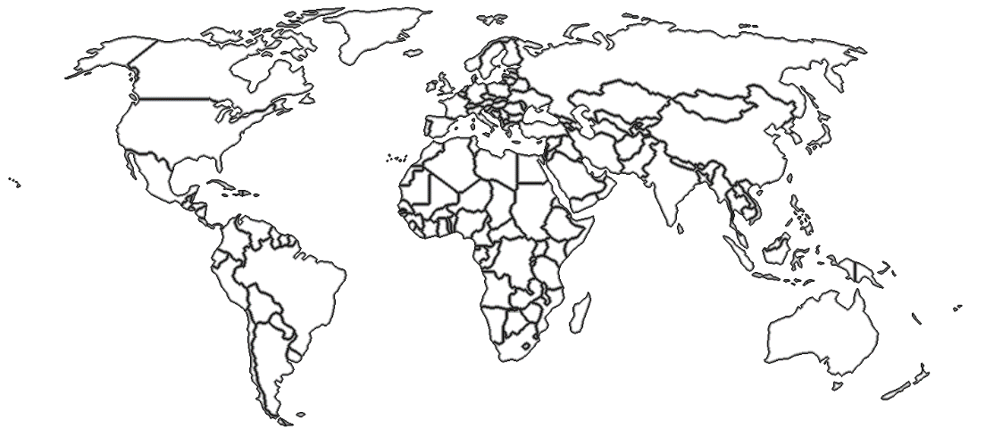

- Explain how jet streams play a vital role in our weather.

- Describe the weather fronts on a map and identify their meanings.
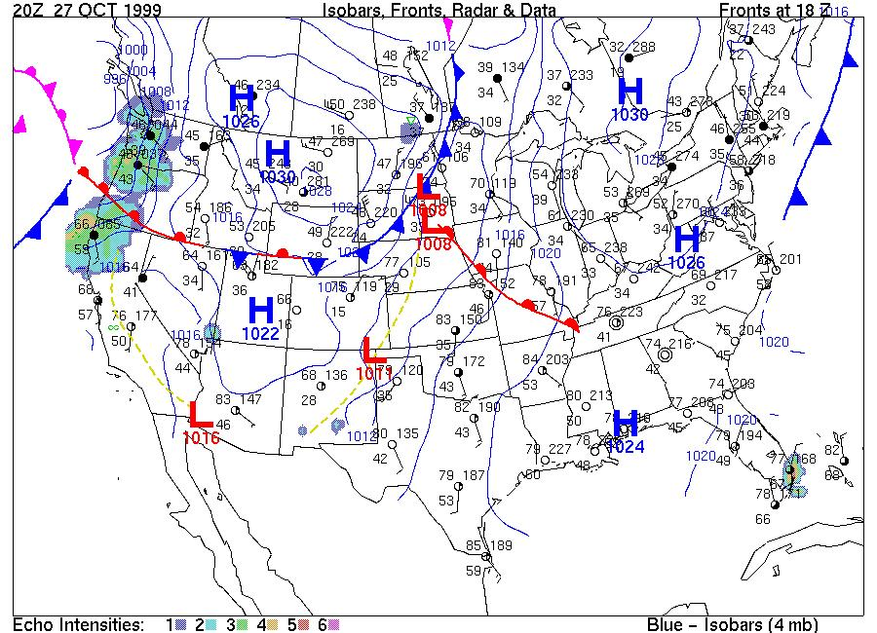

- What are isobars and isotherm?

- Distinguish between high and low pressure systems.

- Identify some modern tools scientists use to predict the weather.

- Differentiate a warning from a watch.

- Draw both the carbon cycle:

- Describe what the big bang means in formation of the universe. How old is the universe?
- Fill out the following table for what is happening for each type of star
Type of Star | Beginning of life of the star | End of life of the star | When the star explodes as the last part of it’s life | After it explodes
Normal/Medium Star
Massive Star |  |  |  | 1.  2.

- Fill out the following table for what elements are being formed:
Big Bang
Type of Star | Beginning of life of the star | End of life of the star (red giant or super red giant) | When the star explodes as the last part of it’s life
Normal/Medium Star
Massive Star

- What evidence supports the big bang? (4 things)

- What is spectral analysis of light and what does it tell us about stars?

- What is a red shift and what is a blue shift? What does it tell us about galaxies and our universe? Who discovered this?

- What do microwave receivers tell us about the solar system?

- What is radioactive decay?

- How can radioactive dating (based on decay) determine the age of rocks or our solar system?

- What is the Nebula Theory and how has it set our planets in rotation?

- What evidence supports nebula theory?

Describe the major contribution to astronomy of each of the following scientists:

- Copernicus-

- Galileo-

- Einstein-

- Hubble-
______________________________________________________________________
- What causes gravity on different planets? Which planet has the most gravity and why? Which planet has the least gravity and why?

- If we were to travel to other planets what would happen to our mass and what would happen to our weight?

- Which object in our solar system has the most mass? What evidence supports this?

- How long does it take for light to travel in one second?
How fast does light travel from the sun to earth?
From the moon to earth?

Which light source is older? Does this mean the object is closer or farther from us?
- Nearest Star (Alpha Centauri)-

- Andromeda Galaxy –

- The Sun-

- Hubble Deep Field Galaxies-
____________________________________________________________________
61.– 77. Name the Major Plates in the picture below:
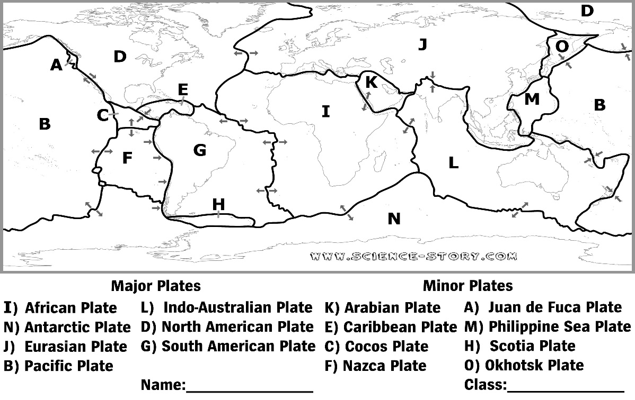
78-81. Name each of the scientists that helped develop todays theory of plate tectonics and write down evidence that supports them.
Scientist | Theory Name | Main claim: | Evidence(s): | Accept (Yes or No)
Abraham  Ortelius | None
Alfred Wegener | Continental Drift
Harry Hess | Plate Tectonics

82. – 84. List the types of plate boundaries and draw the movement of each in the spaces below.
Plate Boundary
Picture of the Movement
Types of Land Formations Created | Continental to continental Crust | Continent to Oceanic Crust

85. - 89. Describe in the picture which way the plates are moving and which rock will be the least dense & coolest, most dense & coolest, least dense & hottest.
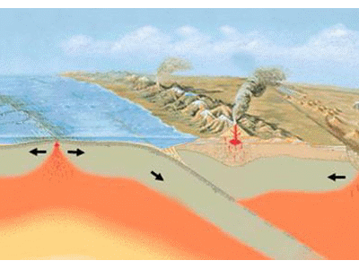

Students read a newspaper article about particulate pollution falling on snowpack. The researcher is trying to find out if the snow melts differently when it has this darkened surface. The students design an experiment to test this question. The students collected the following data on their snow experiment.

Amount of Snow Remaining
Snow patch | After 2 hrs | After 4 hrs | After 6 hrs | After 8 hrs
Control 1 | 90% | 80 % | 75% | 70%
Control 2 | 88% | 82 % | 76% | 71%
Control 3 | 90% | 81% | 74% | 70%
Average for Controls
Test 1 | 85% | 76% | 54% | 40%
Test 2 | 86% | 75% | 55% | 41%
Test 3 | 84% | 76% | 55% | 40%
Average for Tests

90. Calculate the average for the controls and test.

91. What is the independent variable for this test?

92. What is the constant variables for this test? How is this similar to the controls?

93. What is the dependent variable for this test?

94. Graph the Data to show for the experimental test. (Independent variable on the x-axis, Dependent variable on the y-axis)

95. What should the conclusion be for this experiment?

96. – 99. Define and give an example of feedback loops.
Types of Feedback Loops | Definition | Example
Negative Feedback Loop

Positive Feedback Loop

100.-102. Use the graphs (given by Mrs. Orgill or on Mrs. Orgill’s webpage) to determine the main conclusion of each set of data.
100. Availability of Fresh Water in 2000 | 101. Global Population & Cereal Production | 102. Death from Urban Air Pollution

103. What is the difference between natural hazards locally and globally give an example of each

