Name:__KEY ________ *** Get answers for the Guided notes from the “Types of Energy. ppt”

What is Energy?
- ____________________ is the ability to cause _______________________!

- Any type of _____________________ will require some type of energy

- Energy is either _________________________ (taken in) or _____________________ (given off) during a physical or chemical change.

- Some Examples are: Heat, ________________, Light, ____________________, Electrical, Radiation, ___________________________ (motion). Etc.

- Most of the energy found on earth is due to the influence of __________________________!

Energy is always in a _____________________________…

- Meaning it is always ______________________________ from one _________________to _______________________.

- This is an important law of nature called:
“Law of _______________________ of _______________________”

~ “You cannot____________________ or __________________________ energy”

ENERGY IN ACTION (Give an example of each)
Example:
_____________________ ENERGY:__________________________________________

_____________________ ENERGY:__________________________________________

_____________________ ENERGY:__________________________________________

_____________________ ENERGY:__________________________________________

_____________________ ENERGY:__________________________________________

_____________________________ ENERGY:__________________________________________

_____________________________ ENERGY:__________________________________________

_____________________ ENERGY:__________________________________________

_____________________ ENERGY:__________________________________________

Quiz yourself: What type of energy is the following? Answer:
- 1. Using a saw to cut a piece of wood in half. 1.

- 2. The explosion of fireworks. 2.

- 3. The melting of an ice cube. 3.

- 4. The glow of fluorescent light. 4.

- 5. Boiling water on a stove. 5.

- 6. Dropping a glass beaker onto the floor. 6.

- 7. The sun’s rays 7.

Moving Molecules and Thermodynamics

- ____________________________ (or Heat) energy can be either taken in or given off from

substances. The amount of energy that is added or removed changes the _________________

_________________.

- As you have learned, the molecules_____________________ determines the______________ of Matter.

- Solids are__________________/fixed; Gases are _____________________;

- Liquids are in between: _____________________ speed.

Each Group is to describe the object they are given and what type of energy (E.) that is being used:

Group 1: (Flashlight) Group 2: (Food Clock)
Battery (Chemical E.) to Wires (Electrical E.) Food (Chemical E.) to Wires (Electrical E.) to
to light bulb (Light E.) Digital Clock (Light E.)

Group 3: (Newtons Cradle) Group 4: (Solar Cricket)
Ball pulled up high (Gravitation E.) & released Solar panel picks up sun (Light E./Solar E.)
(Mechanical E.) to the wires (Electrical E.) to the bug moving
(Mechanical E.)

Group 5: (Heat Sensor) Group 6: (Electric Pencil Sharpener)
Rod picks up Heat (Heat E.) to wires (Electrical E.) Wires (Electrical E.) to sharpener moving
To Battery (Chemical E.) to wires (Electrical E.) (Mechanical E.)
to Digital Numbers glowing (Light E.)

Group 7: (Rubber Band) Group 8: (Radiometer)
Stretch rubber band (Strain E.) to the Release Sunlight (Light E./Solar E.) heats up the black
(Mechanical E.) panel & white panel reflects on to black panel
(Heat E.) which causes the panels to rotate
(Mechanical E.)
Seeing Energy in Everything
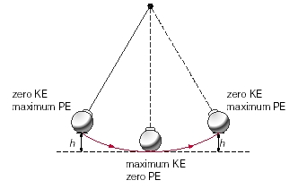
1. Draw a picture of a pendulum.
2. What type of energy is transferred back and
forth with the pendulum motion?
Bottom: fastest and has the most kinetic energy.
Top: Slowest and stops for a split second and has the
Most potential energy.

3. What happens to your eyes when the lights turn on? 4. Turns off?
Pupils get smaller to allow less light in. Pupils get bigger to allow more light in.
___________________________________________ _________________________________________

5. Name another example of an animal responding to energy.
-Dog panting to cool down. Animals hibernate to save energy in the winter. We shiver when cold and sweat when warm.

6. Name the energy transfer for the following items: 1) flashlight, 2) electric fan, 3) plant making an apple.
1. Flashlight- Chemical energy to electrical energy to light energy.
2. Electric Fan- Electrical energy to Mechanical energy.
3. Plant makes an Apple - Solar energy to Chemical Energy.
Heat Energy

Analysis: Fill out this chart for energy transfer:
 | Radiation | Conduction | Convention
Definition | Electromagnetic waves travel thru space. | Heat transfers by direct contact. | UP and down movement of heat through gases and liquids.
How it is demon-  strated | A house warms up in the sun. | Hot metal pan (even the handle of the pan will heat up). | The stove creates:  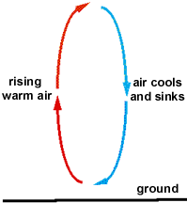
What medium did it travel in? | Outerspace, gases, liquids, and solids. | Solids | Gases & liquids
An example from real life | Heated air from a fire or the greenhouse effect | A hot seat belt on a summer day | Water boiling. Swimming where the pool is colder lower.
Important because | The sun keeps our planet warm and livable. | Electricity is conducted also by conduction. | Movement in the mantle causes plate tectonics.

Conclusion: Heat energy can be transferred by direct contact, empty space, or can rise up and then cool down creating convection currents.

Heat Transfer Lab: Underline what is highlighted.

Introduction: Heat is transferred between objects in 3 ways, conduction, convection, and radiation. In this lab you will observe and identify each type of heat transfer. Be careful to follow the instructions to each experiment carefully so that they will work. Read the background information on types of heat transfer to help you identify which one is occurring in each experiment.

Types of Heat Transfer: Conduction is heat transfer between two objects that are touching each other. When two objects touch and one has a higher temperature than the other; heat is transferred to the object with the lower temperature. When you touch something hot it feels hot because heat is being transferred from the object to your hand. When you touch something cold it feels cold because heat is being transferred from your hand to the object.
Convection is the transfer of heat between molecules of a liquid or gas as they move in a circular pattern due to changes in temperature and density. For example, when you turn on a lava lamp, the wax at the bottom heats up and begins to melt. As the temperature of the wax melts it becomes less dense so it starts to rise. As it rises it gets farther from the heat source, so it starts to cool. As it cools it becomes denser and sinks; starting the process over. Heat rises, cool sinks (hot molecules move apart creating less density)
Radiation occurs when heat is transferred between two objects that are not touching each other. In radiation, heat is transferred from one object to another by electromagnetic waves of energy. For example, when you stand in sunlight you can feel the energy that traveled to your body through electromagnetic waves across millions of miles distance.

Safety Precautions: Be careful with glassware so that it doesn't crack or break. Be careful not to spill. Do not touch light bulbs, the heat pad, or any other hot object. Use a hot pad to carry hot objects from one place to another.

Procedures. Write the data for each experiment on your paper. If there are questions for the experiment, answer them. Write a summary paragraph for each experiment.
Experiment 1:
Materials: 2 thermometers, 2 dark cloths, heat lamp
- Get two thermometers. Record the temperatures of the classroom in °Celsius for 0 minutes.
- Wrap the thermometers in dark cloths, label it with your group's name, and place one wrapped thermometer in front of a heat lamp and leave the other on your table.
- Draw the table below on your paper and record the temperature of the thermometer every 5 minutes for 20 minutes. (You may move on to other experiments once this one is set up.)
Time | Temperature °C  With light | Temperature °C  Without light
0 minutes | 22 °C | 22 °C
5 minutes | 25 °C | 22 °C
10 minutes | 27 °C | 22 °C
15 minutes | 29 °C | 22 °C
20 minutes | 31 °C | 21 °C

- Write 1-3 sentences explaining the cause of change in temperature experienced by the thermometer. Make sure you identify the objects that heat is transferred between and state what type of heat transfer is taking place Radiation is when things get warmer by indirect contact. So the black cloth got warmer under the light. The black cloth without the light got cooler.
Experiment 2:
Materials: hot water, cold water, small glass bottle with a lid, 4 small marbles or rocks to weigh down the small bottle, 1000 mL beaker, paper towels, hot pads

- Pour 800 mL of cold water into a 1000 mL beaker. Place paper towels under your beaker in case it spills during the experiment.
- Get a small glass bottle and put 4 small marbles or rocks in it. Fill the bottle with colored hot water.
- Carefully lower the glass bottle into the cold water so that the bottle sits upright in the water. Do not let any of the hot water spill as you lower it into the 1000 mL beaker.
- Draw a picture of your results. Draw arrows inside your picture to show what direction(s) the water moves and color the different temperatures of water different colors.
- Draw and color another picture of your experiment after all of the hot water has moved out of the glass bottle.
- Write 1-3 sentences describing the movement of hot water out of the glass bottle as well as any movement of the cold water. Explain why the water moves in the way that it does. Make sure you relate the movement of water to its temperature and density and state what type of heat transfer is taking place.
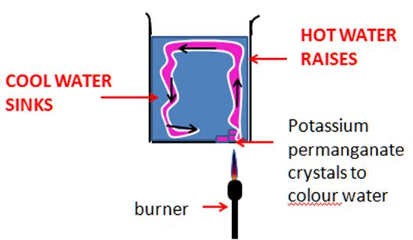
Hot material move faster away from each other and become less dense. Cool materials move slower and are therefore closer together, so they are more dense. That is why you get cold liquids or gases sinking and hot liquids and gases raising.

Experiment 3:
Materials: 100 mL beaker, hot water, hot pads, metal spoon and a wooden splint, chopstick or popsickle stick.
- Get a 100 mL beaker.
- Hold the beaker in your hand. Does it feel hot or cold? Cold glass
- Pour hot water into the beaker. Be careful not to spill. If needed, use a hot pad to carry the beaker back to your desk.
- Touch the side of the beaker with two fingers. Does it feel hot or cold? How does its temperature compare to before you poured the hot water in? It feels warmer when the hot water is in it. At first it felt colder.
- Place a metal spoon and wooden object in the water and allow them to sit for 5 minutes. Record how each feels. The metal spoon feels warmer than the wood chopstick.
- Write a 1-3 sentences explaining the cause of change in temperature experienced by the beaker and spoons. Make sure you identify the objects that heat is transferred between and state what type of heat transfer is taking place. Metals & Glass can conduct hat better. Metalssahre electrons between atoms, so heat and electricity move easily. That’s why the metal feels hotter than the wood. Wood cannot transfer heat as well.

Energy transfer in major Energy providers
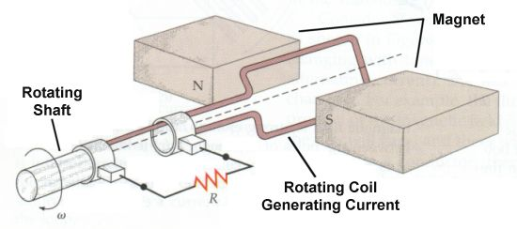
Directions: Go to each of the following websites and determine the energy transfer on each ofthe different ways energy is produced from resources on earth.

First off: how do generators create electricity? To find the answer go to:
http://www.hk-phy.org/energy/power/act_ac_gen_e.html http://www.aerospaceweb.org/question/propulsion/q0209.shtml

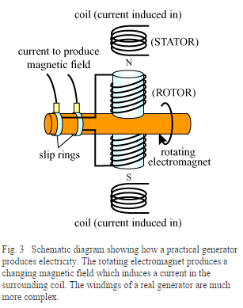

- Motor moves = mechanical energy
- Coil moves between two magnets = electrons moving
- Creates electrical energy.

Now research different power plants, explain the energy transfer at each step.

- Go to: http://www.duke-energy.com/about-energy/generating-electricity/coal-fired-how.asp
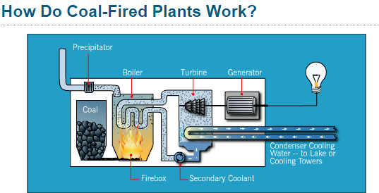

1. 2. 3. 4. 5.

Chemcial Heat Mechanical Mechanical Electrical

- Go to: http://energy.gov/eere/wind/how-does-wind-turbine-work
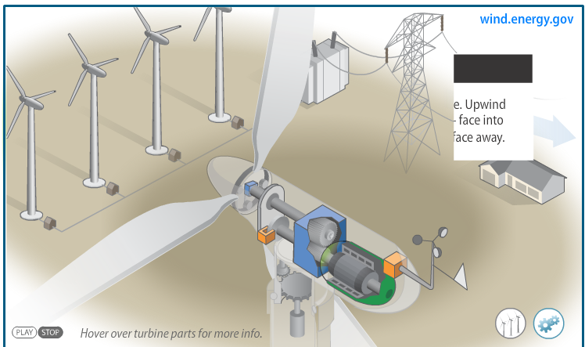

1. 2. 3.

Mechanical Mechanical Electrical

Please research the rest online and determine the correct energy type.
- Go to: http://www.duke-energy.com/about-energy/generating-electricity/nuclear-how.asp
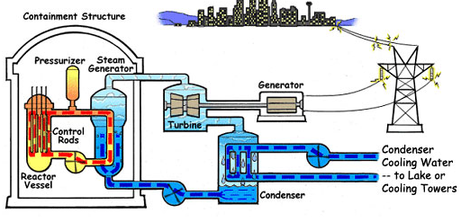

1. 2. 3.

- Go to: http://www.nexteraenergyresources.com/what/solar_works.shtml
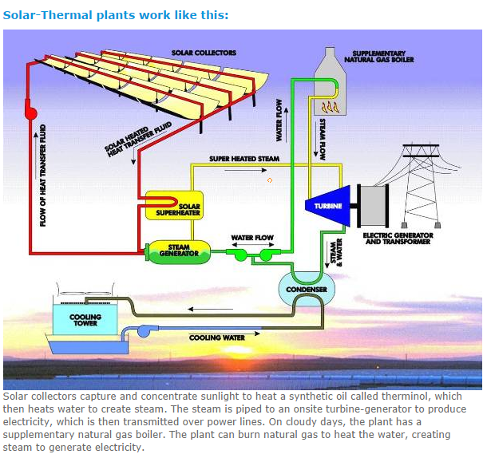

1.

2.

3.

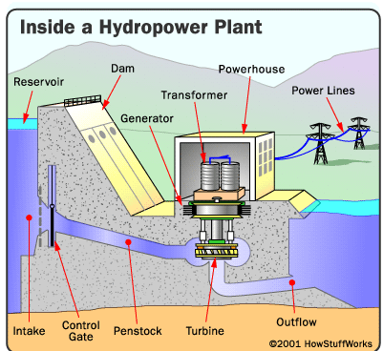

- Go to: http://science.howstuffworks.com/environmental/energy/hydropower-plant1.htm or http://water.usgs.gov/edu/hyhowworks.html

1.

2.

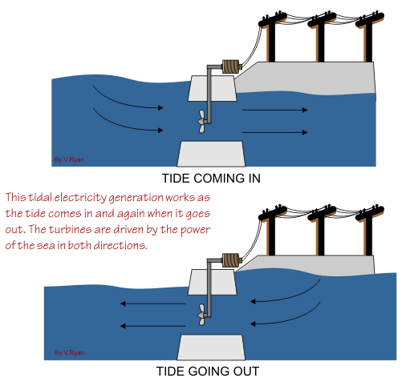

- Go to:
http://technologystudent.com/energy1/tidal1.htm

1.

2.

Review:
- What is kinetic energy?
- What is potential energy?
- What is the relationship between the two?
Kinetic Energy is Energy in Motion or Energy that is happening.
Potential Energy is stored energy.
The relationship is that they change from one form to another.

- Name five types of kinetic energy and four types of potential energy and define what they mean.
Kinetic Energy Types:
Heat Energy – particles moving & generating heat
Sound energy- when particles vibrate the air around them
Light energy- energy from particles called photons
Mechanical energy- energy in motion or from movement
Electical energy- energy from electron transfer

Potential Energy Types:
Gravitational energy- energy from something being up high away from the earth’s center so that it has the ability to be pulled down to the earth’s center
Strain energy- energy from something being pulled and would easily go back to its original shape.
Chemical energy- energy from the bonds between atoms (like food)
Nuclear energy- energy from the nucleus of an atom being split a part or put together.

- Draw a roller coaster and explain where potential energy would be the greatest and the least. Then explain where kinetic energy would be the greatest and then the least.
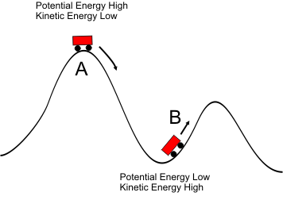

- Describe the energy transfer of:
- A stretched elastic cord: Potential Energy as it stretches (when it releases it would be Kinetic)

- Logs burning on a campfire: Chemical Energy stored in the wood to Heat & Light energy as it burns.

- When a flashlight turns on: Chemical Energy in a Battery to Light Energy as it shines.

- Describe how why a lizard would want to go on a rock if his temperature was low:
It responds to heat energy and light energy from the sun warming up the rock.

- What have scientists done to increase some people’s ability to hear sounds?
The development of hearing aids helps a people hear better.

- What have scientists done to allow us to see farther out in space?
They have developed telescopes with highly accurate polished lenses.

- Draw a picture of light on a wall, what happens to the energy as it travels farther out from the center?
As the energy travels outward its energy decreases.

Describe the three types of heat transfer and an example of each:
Heat type | Definition: | Example:
9.  Conduction | Heat transferring in a solid | Metals are good conductors, like a hot metal seat belt in the summer
10.  Convection | Heat transfer from hot liquids or gases rising and color liquids or gases falling | A stove causes the hot air to move upward and the cold air to move down
11.  Radiation | Heat transfer from a photon of light | The sun heat up a house  The sun heats up a greenhouse.

12. What happens to the speed of particles as they are heated?
As particles heat up they move faster, this can cause them to change phase from a solid to a liquid to a gas.
For example,
Ice is a solid and the particles move slowly, water is a liquid where the particles are warmer and moving faster, water vaopor is a gas where the particles are even hotter and moving very fast in every direction

