ANSWER KEY: Vocabulary Packet 2nd Trimester
Word | Definition | Use in a Sentence | Real Life Example
Solar Energy | Energy that comes from the sun like photons of light | Solar energy provides the energy for plants to do photosynthesis
Chemical Energy | Energy stored in the bonds of atoms | Chemical energy is stored in the food we eat or the food animals eat
Heat Energy | Energy from the sun can become energy in animals moving | When animals eat food they create heat energy and can move (mechanical energy)
Mechanical Energy | Energy because something is moving | We eat food (chemical energy) so that we can run (mechanical energy)
Energy Flow | How energy from the sun can become energy in animals moving | Solar energy Chemical energy Mechanical energy
Predator | An animal that eats another animal | When I eat a chicken I am a predator
Producer | A plant that makes energy from the sun | A producer is a plant that produces food like a potato
Consumer | An animal that eats a plant or another animal for energy | If I eat a baked potato, I get energy that allows me to move and I am a consumer
Food Chain | Shows one way flow of energy in an ecosystem | Tree catapillar chicken person
Food Web | Shows multiple ways energy can flow in an ecosystem | 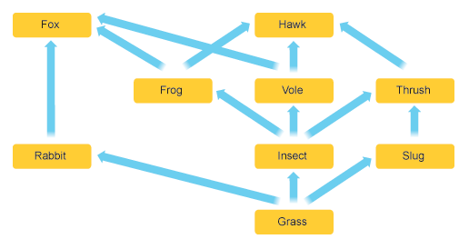
Prey | An animal that gets eaten by another animal | If I eat the chicken, the chicken is the prey
Resources | The available food and substances in an ecosystem | The habitat or ecosystem had valuable resources the animals needed such as water
Mutualism | When two organisms both benefit from each other | The ox pecker eats parasites off the rhinos back
Parasitism | One organism benefits by taking nutrients, which hurts the other | Tapeworm in an animal’s gut
Commensalism | One organism benefits from the other and the other doesn’t benefit or get hurt | Hermit crab takes a discarded shell from the snail (who doesn’t care)
Competition | When two organisms want the same resource | Owls and hawks both want to eat squirrels in the same area
Environment | Place where living things are and interact (both abiotic and biotic) | Pond where fish, algae, lilies or worm or dirt are all together
Capacity | How much an environment can support a living thing | 10 square miles of wood can support 200 deer

Word | Definition | Use in a Sentence | Real Life Example
Volcano | When magma in the earth rises up in cracks to eventually get released at the surface | Volcanos happen at convergent (), divergent ( ) or transform boundaries
Earthquake | when plates are being moved by the magma moving in convection currents, then plates get stuck & then snap creating an earthquake | The longer the plates are stuck the bigger the magnitude of the earthquake
Weathering | When materials are subjected to wind, snow, rain and are changed from it | Weathering causes rocks to become smaller (or to become sediments)
Minerals | Solid crystals that make up rocks | Granite is made up of mica, quartz, hornblende, feldspar & other minerals
Fossils | The hard part of the animal that gets preserved by water & sediments | Only sedimentary rocks can form and keep fossils
Sedimentary | Small rocks (sediments) that are stuck together when water evaporates out leaving minerals that cement the rock | Conglomerate is a sedimentary rock where pebbles are stuck together by minerals
Word | Definition | Use in a Sentence | Real Life Example
Magma | Liquid rock or lava that can cool to become solid rock | Magma is rock that is 1300 degrees F to 2400 degrees F
Metamorphic | Rocks that have been squished by heat and pressure (deep in the crust) | Granite turns into gneiss when it is deep in the crust (many miles down under earth’s surface)
Rock Cycle | When rocks change from one form to another | 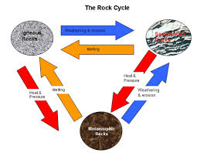
Igneous | When lava cools it forms this kind of rock | The two types of igneous rock (that cool from lava) are 1) Intrusive rock cools slowly 2) Extrusive rock cools quickly
Sedimentation | When sediments get cemented or stuck together by water evaporating out | Sandstone is sand that is stuck together by minerals
Deposition | When sediments get settled or left in one place like at the bottom or a lake or river (happens before sedimentation) | Pebbles gather in one place will eventually make conglomerate.  Sand and clay will gather in one place based on water flow.
Geology | The study of earth’s surface (rocks) | Geology studies how rocks are made and recycled
Paleontology | The study of ancient earth (from the rock record) | Paleontology studies how old rocks are and what fossils are in the rock.
Independent Variable | What is chosen to be tested in a science experiment | Testing the age of the different rock layer would be the chosen independent variable.
Control Variables | What is kept the same during all the tests | All go through radioactive data, All the same geologic formation, so these are the control or constant variables.
Dependent Variables | The results from the tests | How old each rock layer is (data)
Gravitational Force | What pulls all things towards Earth’s center because Earth has so much mass | Gravity pulls rocks down and helps break them into smaller pieces (sediments)

