Name:_Answer Key __ Earth Science Final Study Guide: Both Trimesters

Define the following:
- Surface tension: Describes how water can stick together and make a layer for animals (bugs) to sit on top of the water. Surface tension plays a roll in capillary action where trees pull up water from the roots into the higher branches.

- Condensation: When water as a gas turns into a liquid (inside clouds)

- Polar: Describes water having a positive charge on the hydrogen atoms and a negative charge on the oxygen atoms. So when water freezes it expands because the oxygen on one water molecule interacts with hydrogen on another water molecule to form a weak bond that makes water molecules lock into place outward.

- Transpiration: when water on plants turns in to a gas or water vapor.

- Precipitation: When a cloud cannot hold any more liquid water and it rains (saturation point in the cloud)

- Evaporation: When water in oceans, lakes, ponds, etc. turns into a gas or water vapor.

- Surface runoff: The water that stays on the surface and doesn’t get absorbed into the ground

- Ground infiltration the water pathway that goes into the ground, eventually goes into the water table.

- Determine why communities treat water and how they might manage water as a non-renewable resource.
There is only 3% of the Earth’s water that is fresh (with no salt) & it is therefore needed for human use such as crops, sanitation etc. If we live in a desert or have a drought, we need to treat this water as a nonrenewable resource because it does not replenish easily. We therefore must manage our water as a resource.

- What are physical and chemical properties of water and how they affect water ecosystems?
It can change from a solid to a liquid to a gas or back again at normal Earth temperatures. This helps water store better and be recycled.
Water is also a universal solvent, meaning it can dissolve carbon dioxide and oxygen in the ocean to allow life.

- Describe the water cycle. Where does most of our water on our earth come from?
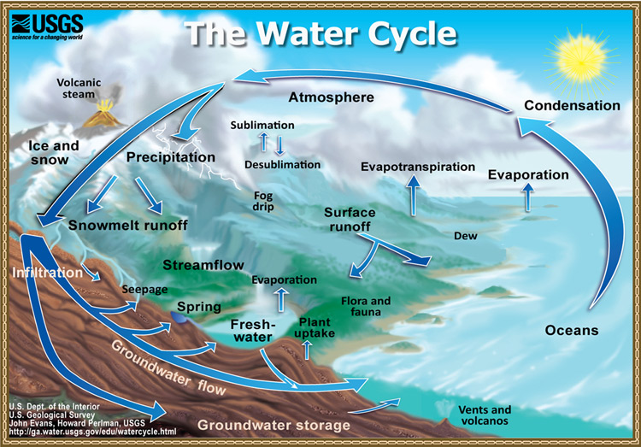
- How does energy move water in the ocean?
Solar energy causes unequal heating and winds. Winds move surface currents. Cold/dense locations cause water to sink.

Describe the physical dynamics of oceans for each of the following words:
- Waves: Waves are affected by winds & the coriolis effect, thus making energy disperse (or get moved about) in certain ways. Increases in wave height occur as the wave hits the shoreline.

- Tides: are affected by the moon and also Earth’s tilt in direction of the moon. It affects the life that can live on the shore and also in erosion or water moving in and out or more access to heat which causes cracking.

- Surface currents: are affected by the coriolis effect and global wind. These currents influence the climate of the continent close to it. For example, Europe has an altitude higher than the U.S. east coast, but rarely gets snow in England, while Maine, New York, Vermont do get snow.

- Deep ocean currents: Water gets pulled down when the water is colder and saltier making it more dense.

- Upwellings: When winds cause water to move away from the shore line, water from the bottom of the ocean comes up from the bottom. This brings lots of nutrients so the area has a lot of life.

- Describe the basic composition of the atmosphere in the types of gases and the percentage of each:
Nitrogen-78% most abundant Oxygen-21%, 2nd most abundant
Water Vapor-0-4% depending on how humid the air is Argon-.93%

Name the five layers of the atmosphere and the most important facts about each.
Atmospheric Layer | Important Facts of that layer.
Top-Exosphere | Blends in with outerspace
Thermosphere | Has the most extreme temperatueres. Can get the hottest (why it’s called thermo)  (gets meteor trails or shooting stars)
Mesosphere | Middle layer  (gets meteor trails or shooting stars) (has some ozone in it)
Stratosphere | Has the most amount of ozone in it
Troposphere | Layer closest to Earth. Has the most weather (tropos means change)

- Explain the significance of ozone in the upper and lower atmosphere
Ozone is 3 oxygen atoms that take turns being positively, negatively, or neutrally charged. Because of the movement of electrons in can absorb ultraviolet radiation from the sun. Ozone helps protect life.

- What is the hole in ozone? What substances cause it? What harm does the hole in the ozone cause?
The hole(s) in the ozone are close the poles. CFCs or Chloroflourocarbons create the hole but since scientists have learned and reported the problem the hole has been decreasing because we have gotten rid of old refridgerators.
If there is a hole in the ozone, it allows for more ultraviolet radiation which can hurt life and cause cancer.

- Describe how energy from the sun moves in the atmosphere (eg. conduction, convection, and radiation).
Radiation-sun’s rays (electromagnetic waves) are absorbed by the atmosphere
Convection-when hot liquids/gases rise and cool liquids/gases sink. These convection cells are Hadley cells and they create winds and weather patterns because hot air rises and cool air sinks.
Conduction-when solids transfer heat. Heat is absorbed in the crust and affect the temperature.

- Illustrate the causes of wind and identify some local winds.
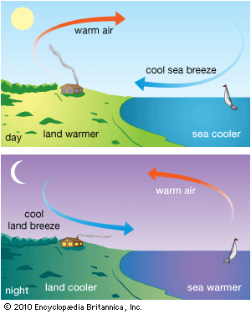

- Differentiate between weather and climate.
Weather is the day to day changes and climate is the average temperatures and precipitation throughout the year.

- Describe how latitude affects climate. Include the three main regions and explain the four seasons (which hemisphere is pointing towards the sun, etc.)

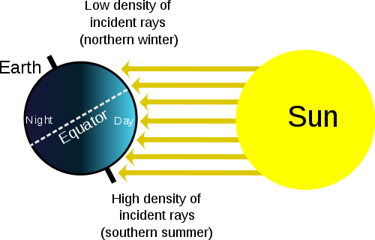
Climates that are closer to the equator have more direct sunlight.
We experience the seasons based on if our northern hemisphere is tilted toward the sun or away from the sun… not based on it’s orbital closeness to the sun.
(the pic on the left would be the northern hemisphere (us) in the winter)

- Summarize 5 natural reasons for climate change.
Volcanic Eruptions- creates solar reflectivity – gets colder
Ocean Current- moves a large amount of heat. El nino years change so the earth is warmer
Earth Orbital changes- the tilt of the earth, even over small amounts can change the climate (example of ice ages)
Solar variations- sometimes the Sun sends out more solar waves/flares than in other years
Plate Tectonics- change ocean currents which affect climates on the continents next to these ocean currents

- Differentiate between global warming and the greenhouse effect.
Greenhouse effect is when the Earth’s atmosphere traps heat in and makes the planet warmer
Global warming-when too much CO₂ is relased into the atmosphere which makes our atmosphere thicker and the atmosphere then traps in more heat.

- Identify two things that humans are doing that could alter the climate.
We burn fossil fuels which increase the amount of CO2 which makes the planet trap in more heat
Cutting down trees (decreases how much CO2 trees are changing into oxygen)

- Describe five main air masses. Include: their characteristics, how they form and how they influence weather.

- Define the Coriolis Effect and be able to
When the Earth spins it creates natural directions for water and wind to move. This creates Hadley cells which are natural places for the Earth to have deserts or more precipitation.

- Draw and name global winds on this map:
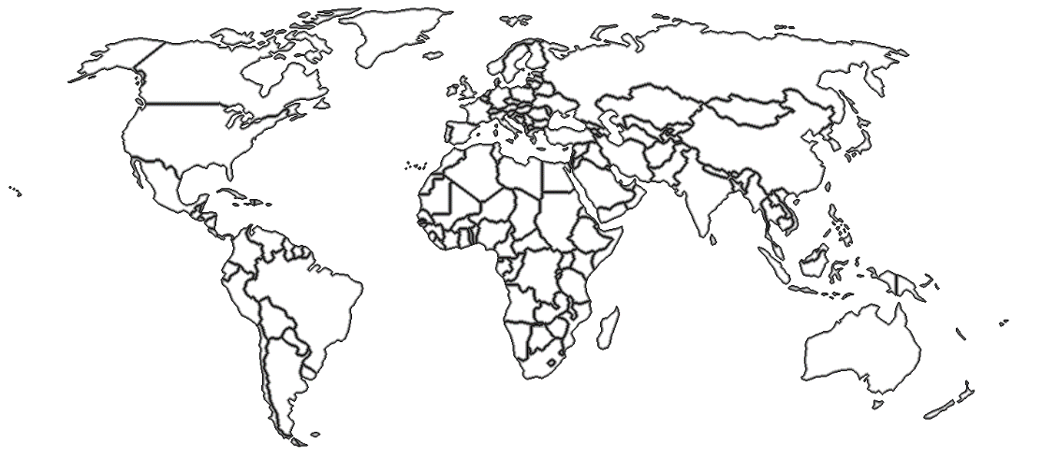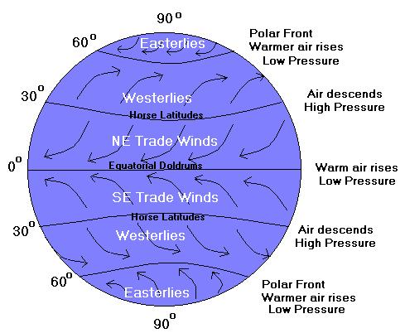

- Explain how jet streams play a vital role in our weather.
Jet streems are fast currents of air flow. It is responsible for moving a lot of air and pressure systems around that alter our weather.

- Describe the weather fronts on a map and identify their meanings.
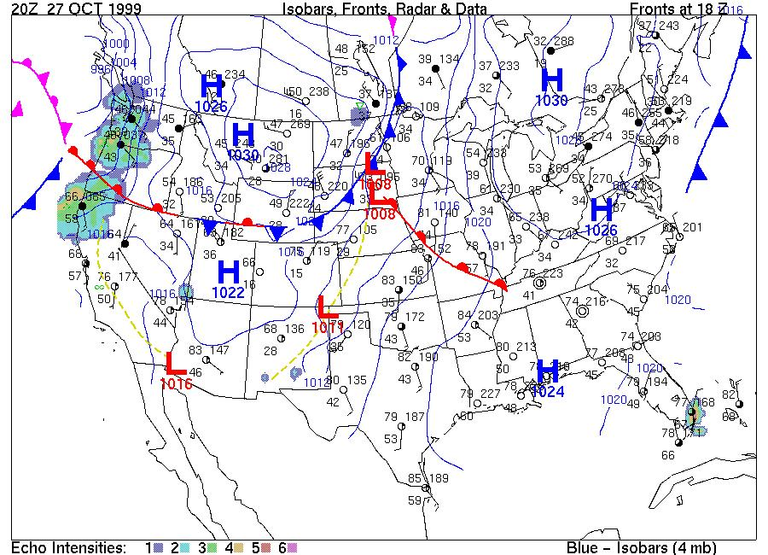

- What are isobars and isotherm?
Isobars- a line that connects all the similar air pressures
Isotherms- a line that connects all the similar air temperatures.

- Distinguish between high and low pressure systems.
High pressure increases evaporation so it has clear skies and calm weather
Low Pressure can produce rain and colder weather.

- Identify some modern tools scientists use to predict the weather.

Satellites Weather balloons Radar

- Differentiate a warning from a watch.
Watch- the potential exists for a severe storm but you should still go about your activities
Warning- severe storm will happen or is happening and you should go indoors.

- Draw both the carbon cycle:
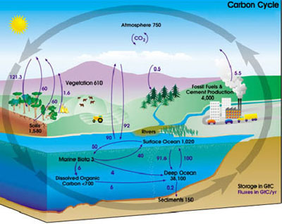

- Describe what the big bang means in formation of the universe. How old is the universe?
When all matter and energy ws in one small location in the universe suddenly exploded outward. About 13.7 billion years ago. (some scientists are debating 14 billion years ago)

- Fill out the following table for what is happening for each type of star
Type of Star | Beginning of life of the star | End of life of the star | When the star explodes as the last part of it’s life | After it explodes
Normal/Medium Star | Normal Fusion occurring (blue, white, yellow look) | Turns into a red giant | Planetary Nebula | White dwarf
Massive Star | Normal Fusion occurring (blue, white, yellow look) | Turns into a super red giant | Supernova | Neutron Star  Black hole

- Fill out the following table for what elements are being formed:
Big Bang
Type of Star | Beginning of life of the star | End of life of the star (red giant or super red giant) | When the star explodes as the last part of it’s life
Normal/Medium Star | Hydrogen into Helium | Makes from He to Carbon or Oxygen | Planetary Nebula
Massive Star | Hydrogen into Helium | Make He up to Iron (Fe) | Supernova makes (Cobalt to Uranium… past iron… heavy elements

- What evidence supports the big bang? (4 things)
- Red shift- most galaxies are moving away from us
- Cosmic Background radiation- left over heat from the big bang, pick up by microwave readings
- Abundance of light elements- 75% hydrogen and 25% helium
- Oldest white dwarfs discovered are 13 billion years old.

- What is spectral analysis of light and what does it tell us about stars?
Each element when excited by energy has electrons jump to a new energy state and as they fall back to their normal energy they give off light. That light for each element will defract in different ways giving a set of spectral lines that’s unique for that element. So if a star or supernova or galaxy makes an element or a spectrum of elements it will come off in different light spectrums. We know supernovas make heavy elements from their light spectrum.

- What is a red shift and what is a blue shift? What does it tell us about galaxies and our universe? Who discovered this?
Red shift is when an element’s light spectrum defraction has each line moved to the red ened and means the object is moving away from us

Blue shift is when an element’s light spectrum is toward the blue end and the object is moving away from us.

- What do microwave receivers tell us about the solar system?
Microwave receives can pick up microwaves or electromagnetic waves at a lower frequency. This shows that there is still heat (we see as static) left over in space and supports the big bang.

- What is radioactive decay?
When an unstable atom (one with too many neutrons) will break down into a new atom/element over time.
Scientists count the radioactive-parent atom and compare that number to the number of atoms it breaks down into (daughter element or particle). The more daughter elements the parent has broken down into means it is older.
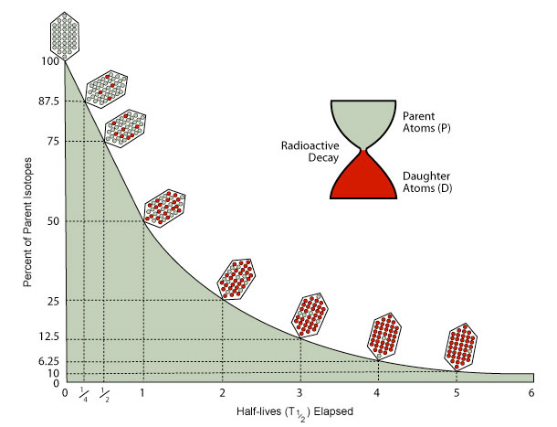
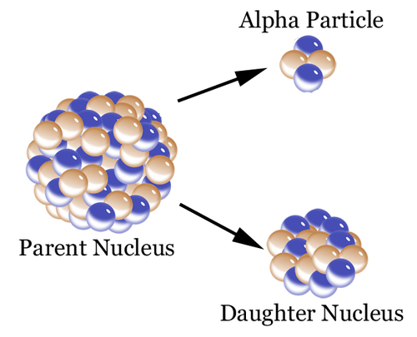

- How can radioactive dating (based on decay) determine the age of rocks or our solar system?
We can count how much decay has happened in the asteroid (or meteorite when it comes into Earth’s atmosphere) and tell that the solar system is 4.6 billion years old. Because asteroids were formed from the same gas and dust that made up our solar system.

- What is the Nebula Theory and how has it set our planets in rotation?
Our solar system was a nebula or a cloud of dust, gas & ice. Until something caused our solar system to star spinning. Gravity caused things to condense to make the sun and the planets.

- What evidence supports nebula theory?
- All planets orbit the sun on the same plane
- All planets orbit the sun in the same direction (counter clockwise)
- Inner planets are made of the same material as asteroids
- Gas planets are out planets formed when the sun ignited with powerful solar flares/wind that pushed the gas the outer planets.

Describe the major contribution to astronomy of each of the following scientists:

- Copernicus-1st to claim the sun was the center of the solar system (heliocentric not geocentric-earth centered=Ptolemy)

- Galileo- built the first telescope and confirmed heliocentric solar system because he could see Venus had phases like the moon.

- Einstein- Thoery of Relativity- large masses bend space time fabric and is why we orbit the sun.

- Hubble- Used large telescopes on blotches that he discovered were galaxies and most are red shifted or moving away from us – light spectra
______________________________________________________________________
- What causes gravity on different planets? Which planet has the most gravity and why? Which planet has the least gravity and why?
The mass of the planet determines its gravitational pull. Jupiter has the largest gravity pull because it is the bigeest planet. Pluto or mercury has the least gravitational pull because it is the smallest.

- If we were to travel to other planets what would happen to our mass and what would happen to our weight?
Mass is how much matter there is and will stay the same no matter what planet you are on.
Weight is how much gravity is pulling on that mass.
85 kg crate will be the same on any planet, but it will weigh 25 lbs on the moon, 160 lbs on Earth, etc.
- Which object in our solar system has the most mass? What evidence supports this?
The sun has the most mass because all of the planets orbit it.

- How long does it take for light to travel in one second? 187,000 + miles in one second (7 ½ times around the Earth)
How fast does light travel from the sun to earth? 8 ½ minutes
From the moon to earth? 1.3 seconds
Which light source is older? Does this mean the object is closer or farther from us?
- Nearest Star (Alpha Centauri)- 4.37 light years (2nd closest)

- Andromeda Galaxy – 2.5 million light years (3rd closest)

- The Sun- 8 ½ minutes of light, or 1 astronomical unit or 93 million miles (closest)

- Hubble Deep Field Galaxies- 12.8 billion light years (farthest)
____________________________________________________________________
61.– 77. Name the Major Plates in the picture below:
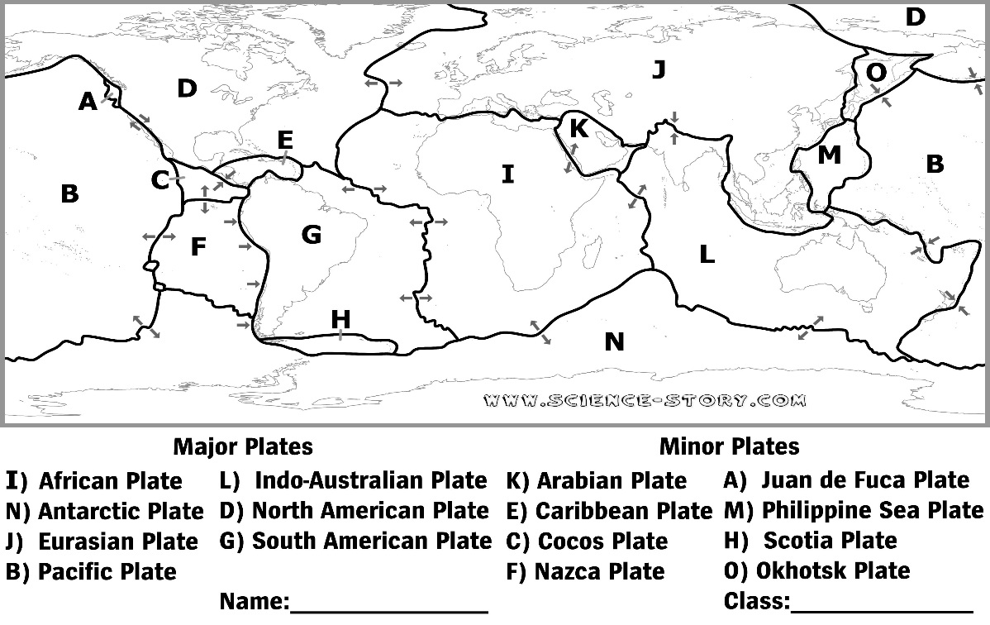

78-81. Name each of the scientists that helped develop todays theory of plate tectonics and write down evidence that supports them.
Scientist | Theory Name | Main claim: | Evidence(s): | Accept (Yes or No)
Abraham  Ortelius | None | Continents were once together | When he made maps he saw the continents looked like they fit | NO
Alfred Wegener | Continental Drift | Continents were once together and have drifted apart | Fossils line up from different continents as well as mountain ranges | No, no mechanism to explain it
Harry Hess | Plate Tectonics | Continents are floating on top of liquid magma and were once together | -Sea floor spreading  -Age of rocks on ocean bottom  -Glacier debris across continents | Yes

82. – 84. List the types of plate boundaries and draw the movement of each in the spaces below.
Plate Boundary | Convergent |  | Divergent | Transform
Picture of the Movement | Moving together |  | Moving apart | Moving side by side
Types of Land Formations Created | Continental to continental Crust  -Mountains | Continent to Oceanic Crust  -Ocean trenches  -Volcanos | -Ocean ridges  -underwater volcano vents | -earthquakes  -gashes

85. - 89. Describe in the picture which way the plates are moving and which rock will be the least dense & coolest, most dense & coolest, least dense & hottest.
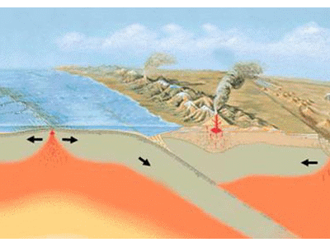

Moving Apart: youngest rocks & hottest rocks
Where the ocean plate is going under the continental plate = most dense and coolest rocks

Students read a newspaper article about particulate pollution falling on snowpack. The researcher is trying to find out if the snow melts differently when it has this darkened surface. The students design an experiment to test this question. The students collected the following data on their snow experiment.

Amount of Snow Remaining
Snow patch | After 2 hrs | After 4 hrs | After 6 hrs | After 8 hrs
Control 1 | 90% | 80 % | 75% | 70%
Control 2 | 88% | 82 % | 76% | 71%
Control 3 | 90% | 81% | 74% | 70%
Average for Controls
Test 1 | 85% | 76% | 54% | 40%
Test 2 | 86% | 75% | 55% | 41%
Test 3 | 84% | 76% | 55% | 40%
Average for Tests

90. Calculate the average for the controls and test.

91. What is the independent variable for this test?
What you are testing it on. White snow vs. black snow by pollution

92. What is the constant variables for this test? How is this similar to the controls?
What is kept the same, same amount of snow, same time left to melt at the same temperature

This is similar to control group which is the group that is considered normal conditions.

93. What is the dependent variable for this test?
The results, how much snow is left after melting for a certain amount of time.

94. Graph the Data to show for the experimental test. (Independent variable on the x-axis, Dependent variable on the y-axis)
x-axis-horizontal- types of snow (white vs black from pollution) y-axis- results- how much snow amount is left after melting

95. What should the conclusion be for this experiment?
That snow that is black from pollution does melt more than plain white snow.

96. – 99. Define and give an example of feedback loops.
Types of Feedback Loops | Definition | Example
Negative Feedback Loop | Reduces the action in the future | 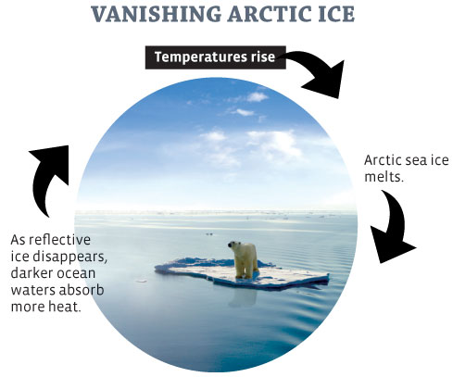
Positive Feedback Loop | Increases the likelihood of the action to occur again | 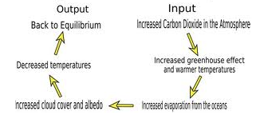

100.-102. Use the graphs (given by Mrs. Orgill or on Mrs. Orgill’s webpage) to determine the main conclusion of each set of data.
100. Availability of Fresh Water in 2000 | 101. Global Population & Cereal Production | 102. Death from Urban Air Pollution

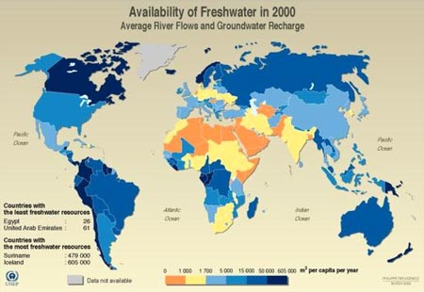

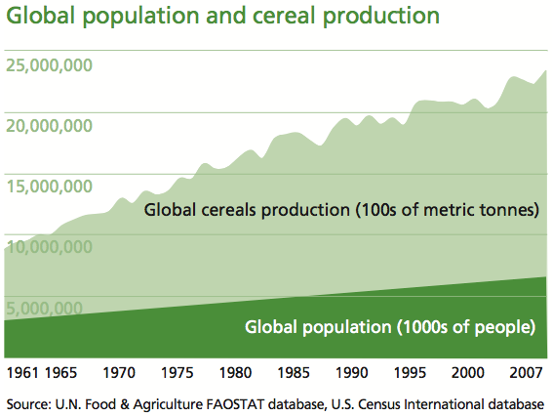
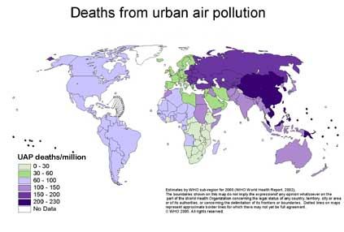
103. What is the difference between natural hazards locally and globally give an example of each
Natural hazards affect a local area = storms, earthquake, etc.
Global natural hazards = affect more places on the globe.
Ex: volcanic eruptions can affect other areas for drought or drop temperature Ex: tsunami

